Data analytics - Task: Netflix Dataset
In this task, you will be required to perform some data analytics steps to analyse a netflix dataset and develop a dashboard.

To complete the tasks below, download the Netflix_titles.csv dataset from Blackboard.
Load the dataset into Power BI.

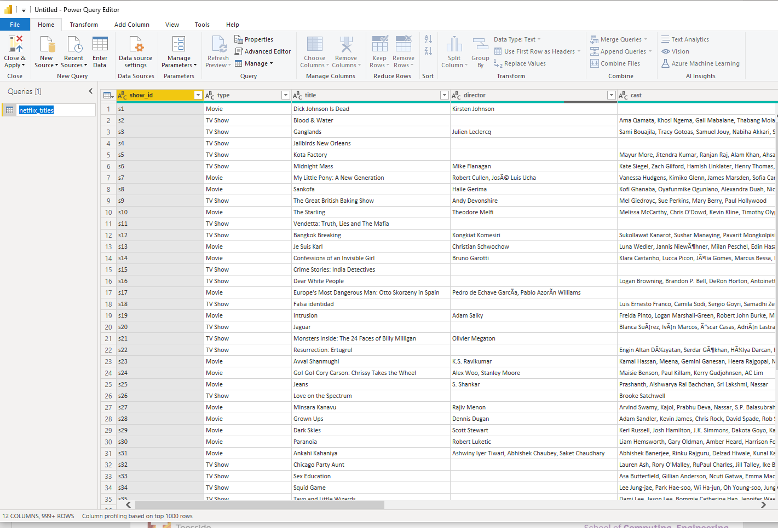

- Create a dashboard to analyse the data and complete the tasks below.
You can use any charts/tools to address the tasks.
For each task, add a screenshot of the chart that you used to answer the question (use the Snipping Tool to select only the chart that contains the answer). Feel free to use Google if you need help and explore new tools.

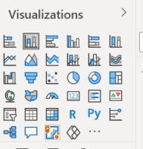
In some cases, you might need to work on the data to
fully answer the questions.
Are you up to the challenge? :)

Slicers are going to be useful for some of the tasks.

Business Questions |  | Answer and Screenshot to support your answer
1 | Which director has made the highest number of Movies?  Do you notice anything “wrong”? How would you address missing values here?
2 | How many directors have made only one movie? | Do you get 1811?
3 | Which directors have made more than 10 movies?
4 | How many movies are released in the year 2020?
5 | How many movies are released in the year 2020 where duration is greater than 60min (how would you make the duration column numeric? You might need to remove the “min” word first, if you haven’t done it yet)
6 | Which year has the highest number of Movies released?
7 | Which year has the lowest number of Movies released?
8 | Create a chart with a map showing the number of Movies as dots related to each country.
9 | Create a chart to show the number of Movies of duration longer than 60 minutes released in each year
10 | Add a Slicer to allow the selection of where the movies are listed in. Your slicer should look similar to the one below (without TV Shows). Then change the title “listed_in” into “Genre”.  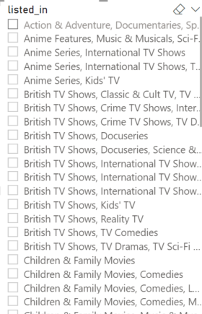
11 | Arrange your charts to develop a well structured dashboard (tiles should be well-aligned, add a title, add borders to the charts, select a common theme colours across the different tiles, etc.). Once you’re done, take a screenshot and post it on Padlet (link below).
The examples\styles below might help you getting inspired when designing your final dashboard
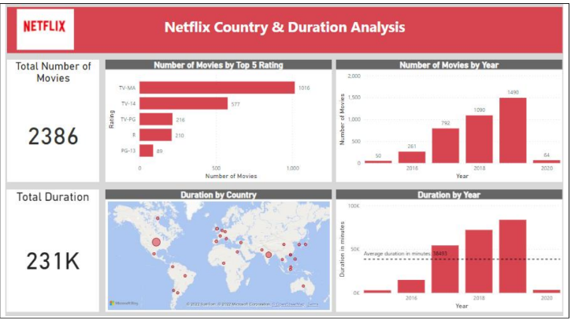
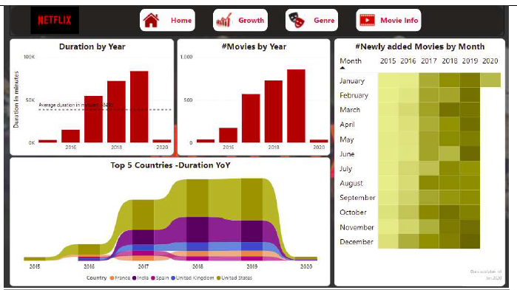
These are buttons used to navigate thorough the report. When you click on them you will go to different pages of the report…how would you do that?
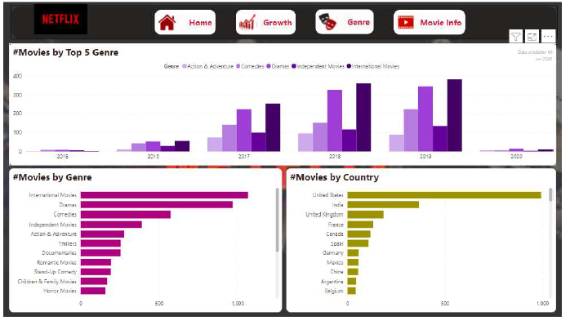

2) Peer-Marking: once you have completed all the questions, compare your result with the person next to you. Do you agree with all the answers? Did you use the same type of graphs?
3) Now, take a screenshot of your final dashboard and share it on Padlet.
In the text option, add another Business-related question that you might get asked about your dashboard.

If you are not sure how to share a file on Padlet, watch this video: Link to video – The video also shows how to add a title to your dashboard.

